SHANDONG ANTE SPECIAL VEHICLES MANUFACTURING CO., LTD

Export Compliance Capacity Statement

I. Basic Enterprise Information
Company Name: Shandong Ante Special Vehicles Manufacturing Co., Ltd
Registered Address: Bei Tianmen Street, High Tech Development Zone, Tai’an City, Shandong Province, China
Uniform Social Credit Code: 91370900613681814B
Main Products: Trailers, Traction Dining Cars, Electric Dining Cars, Low Speed Vehicles (LSV)
Target Markets: United States, European Countries

II. Domestic Compliance Qualifications

2.1 World Manufacturer Identifier (WMI) Certificate
Certificate No.: 5179
WMI Code: H09 / SAT
Vehicle Type: Trailer
Validity: 2025-12-30 to 2030-12-30
Issuing Authority: China Vehicle Identification Number Management Office

2.2 Quality Management System Certification (ISO 9001:2015)
Certificate No.: Q2500597R0S
Standard: GB/T 19001-2016 / ISO 9001:2015
Scope of Certification: Design, development, production and sales (export only) of traction dining cars, electric dining cars and trailers
Validity: 2025-12-12 to 2028-12-11
Certification Body: CSU International Certification Co., Ltd. (CNAS accredited, IAF mutual recognition)

III. Overseas Compliance Qualifications (US Market)

3.1 NHTSA Part 565 Manufacturer Registration
Manufacturer ID: 22049
Applicable Model Years: 2026 — 2039
Registration Date: February 15, 2026
Legal Significance: Registered as a manufacturer with the US NHTSA, legally authorized to assign VINs compliant with FMVSS standards.

3.2 NHTSA Part 566 Manufacturer Information Filing
Submission Date: January 20, 2026
Brand: ANTE
Equipment Types: Trailer, Low Speed Vehicle (LSV)
Legal Significance: Completed manufacturer information filing as required by US federal regulations.

IV. Comprehensive Assessment of Export Compliance Capacity
1. Domestic Production License
Shandong Ante Special Vehicles Manufacturing Co., Ltd. has obtained the World Manufacturer Identifier Certificate (WMI Code: H09/SAT), possessing legal production qualifications for trailers and other products. Status: Compliant.
2. Quality Management System
The company has passed ISO 9001:2015 certification. The certification scope covers the design, development, production and sales (specifically marked as "export only") of traction dining cars, electric dining cars and trailers. Status: Compliant and qualified.
3. US Manufacturer Registration
The company has completed NHTSA Part 565 compliance registration (Manufacturer ID: 22049), covering model years 2026 to 2039. Status: Compliant.
4. US Brand Registration
The brand name "ANTE" has been officially filed as a Doing Business As (DBA) name in the NHTSA database. Status: Compliant.
5. Product Export Compliance Scope
The company has clear compliance coverage for different markets:
For the US market: compliant export capability for Trailers and Low Speed Vehicles (LSV).
For global and EU markets: relying on EU CE certification and the ISO Quality Management System, compliant export capability for Traction Dining Cars and Electric Dining Cars.
Status: Clearly defined.
6. Sales Restriction
The ISO 9001 certificate explicitly states "export only," which perfectly aligns with the company's foreign trade business model. Status: Compliant.

V. Conclusion
Shandong Ante Special Vehicles Manufacturing Co., Ltd. has established a solid global export compliance foundation and completed a dedicated compliance system for the US market. Based on the WMI, ISO 9001, and NHTSA official registration records, the company possesses the full compliance capability to legally export Trailers and Low Speed Vehicles (LSV) to the United States. Meanwhile, relying on CE certification and the ISO Quality Management System, the company also possesses the compliance conditions to export Traction Dining Cars and Electric Dining Cars to global markets, especially the European Union.

Appendix List of Documents
1. World Manufacturer Identifier Certificate (WMI)
2. Quality Management System Certification Certificate (ISO 9001)
3. EU Machinery Directive and Low Voltage Directive Declaration of Conformity
4. Overseas Part 565 Compliance Database Registration Screenshot
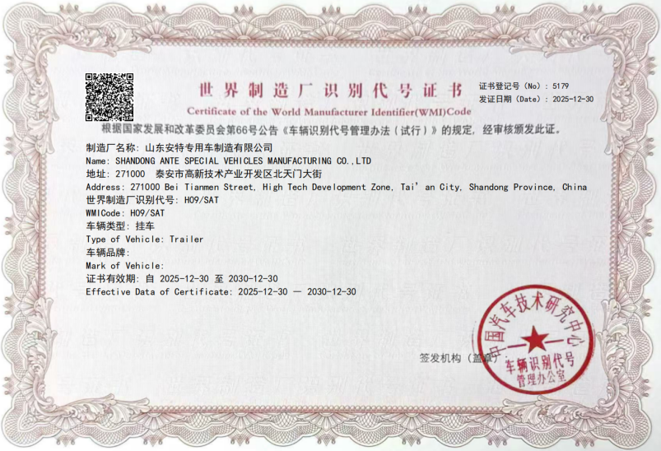
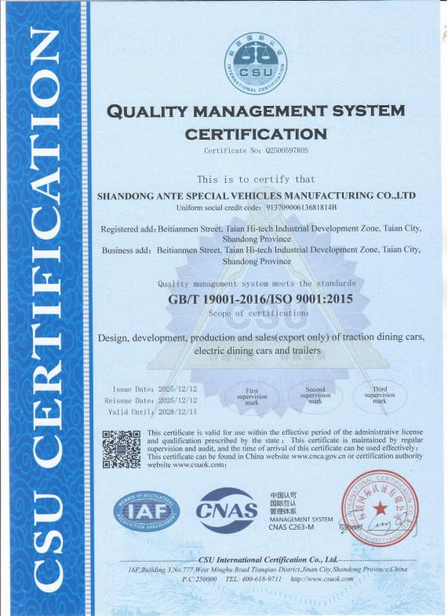
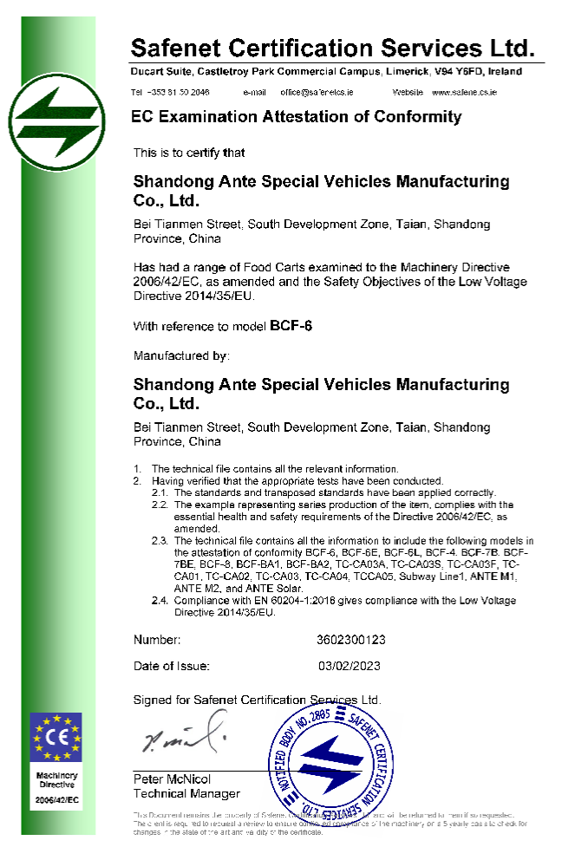
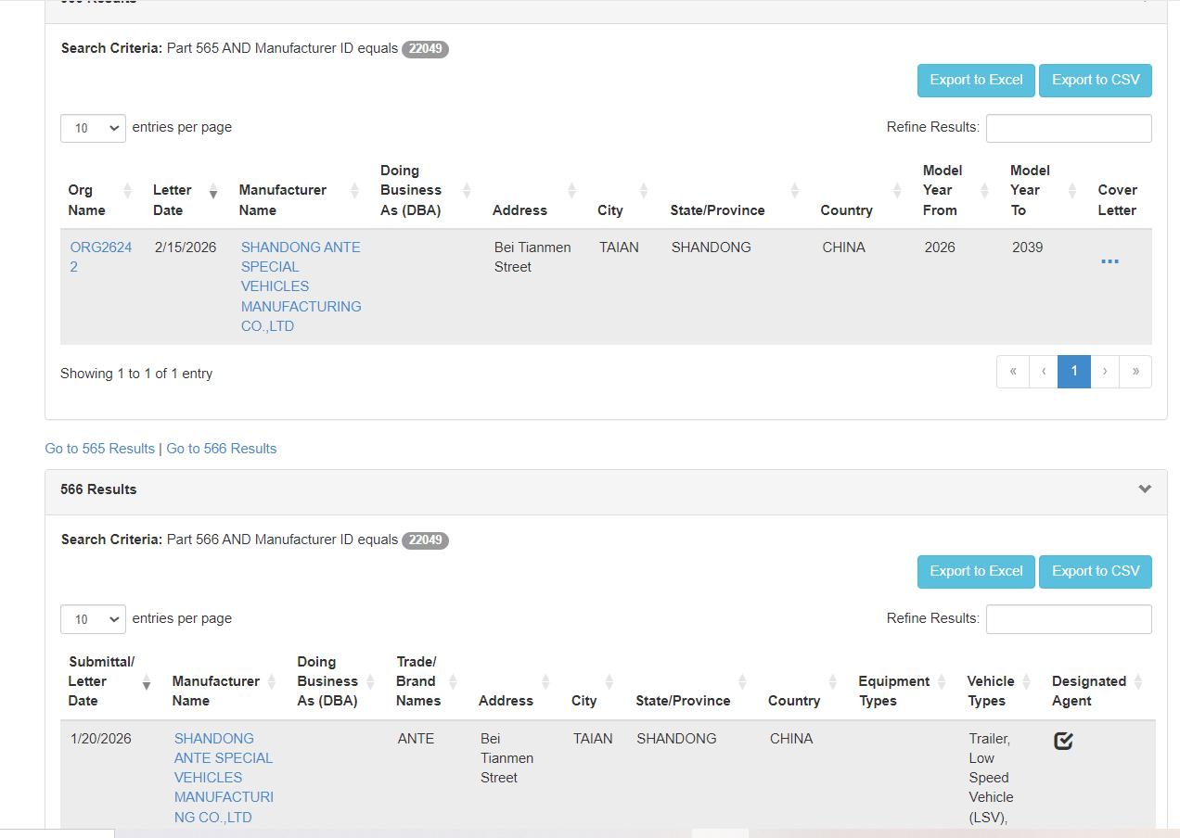

Shandong Ante Special Vehicles Manufacturing Co., Ltd.

